S & M-CM/164/STV-BOOSTER CARDS/12-13/13 dt @ Chennai-6 the 05.06.2012.

Sub: Introduction of Special Tariff Voucher (STV) under prepaid mobile services - reg.
Ref: 1. C.O. lr no: 26-03/2012-T&C-CM Circular No:23/12-13 dt 25.05.2012.

Approval of the competent authority is hereby conveyed for the introduction of Two new STVs under 2G and 3G prepaid mobile services through C-TOP-UP in Tamilnadu LSA (including Chennai Telecom District) with effect from 08.06.2012.

The details are given below:-

Special Tariffs>>> | Validity  (in days) | MRP in Rs.  (incl. of S.Tax)
400 Min Local/STD Any-net call | 30 | 135.00
Unlimited Local/STD On-net Night(11PM to 06 AM) | 15 | 59.00

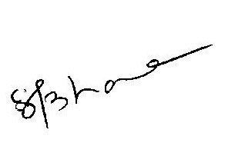
This is for the information of all concerned please.

(S. BAMA)

AGM(Marketing-CM)

044-28290825, 9444979827

To
GM (NW-O CM), Trichy -1/ Coimbatore – For information & necessary action please.
GM(S&M-CM), Chennai Telephones, Chennai – for information please.
GM (F) / Sr. GM (TR) TN Circle, Chennai for information please.
DGM /DE In charge IN – Trichy/Bangalore - for necessary action please.
DGM (N/W-O-CM)/DE Commercial Coimbatore - For information & necessary action please.
Heads of SSAs, -- for kind information and necessary action please.
DGM (Sales), AGM (Sales) & AGM (MKTG II)- Chennai-6 –For information and informing Sales Heads , franchisee managers and retail managers and other Channel partners along with commission structure as applicable.
DGM (CS), Chennai-6 - For information and informing Call Centre/Customer Service Centre Officials and ensure uploading the information on the website “tamilnadu.bsnl.co.in” .
DGM (S&M-CM)/AGM (MKTG-CM), Chennai Telephones, Chennai – for information & necessary action please.

